2.) Write SQL queries for the following tasks:

1. Write a SQL query to retrieve the name, account type and email of all customers

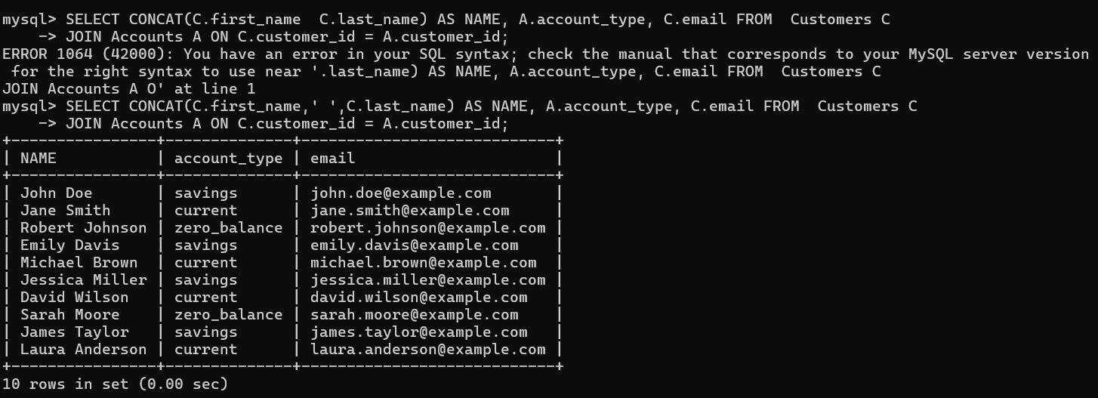

2. Write a SQL query to list all transaction corresponding customer.

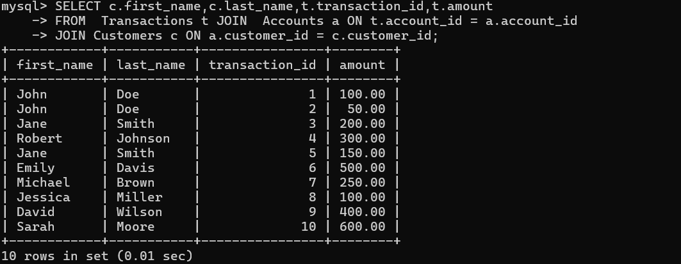

3. Write a SQL query to increase the balance of a specific account by a certain amount.

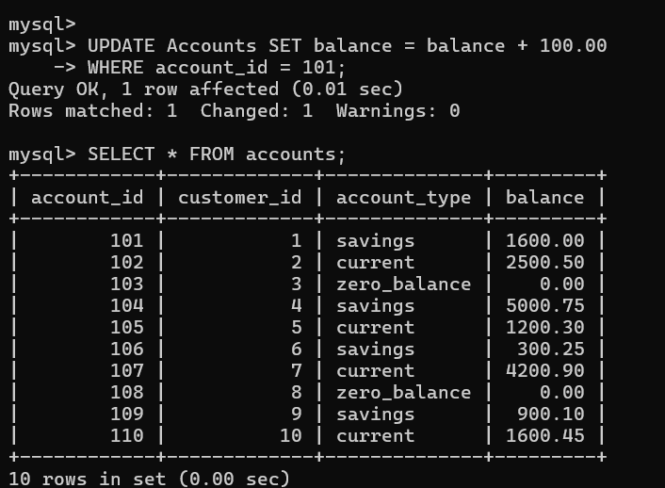

4. Write a SQL query to Combine first and last names of customers as a full_name

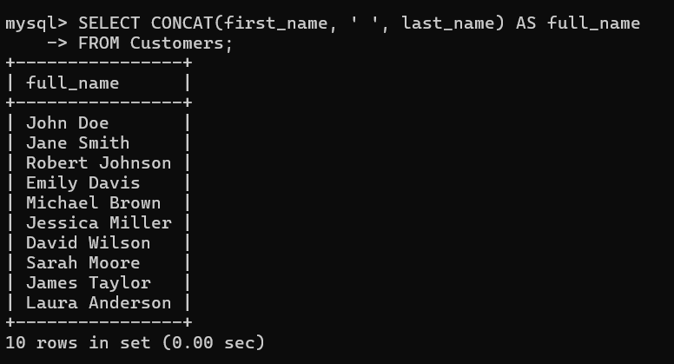

5. Write a SQL query to remove accounts with a balance of zero where the account type is savings. **(NOTE :- NONE OF THE ACCOUNTS ARE DELETED AS THERE IS NO SAVING ACCOUNT WITH BALANCE ZERO.)**

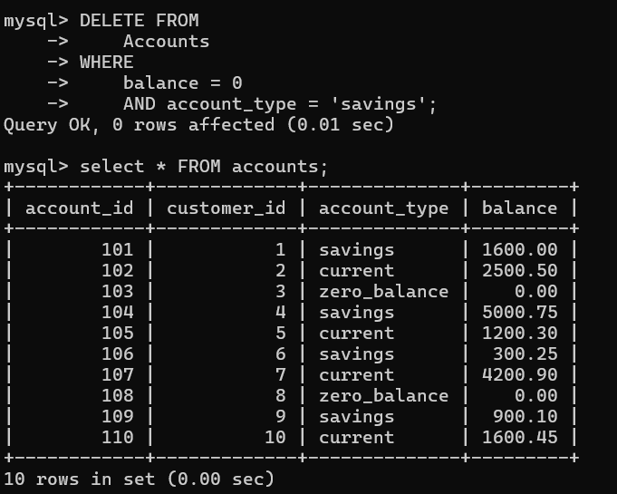

6. Write a SQL query to Find customers living in a specific city.



**NOTE:- THERE IS NO CLOUMN NAME SPECIFIED WITH CITY IN THE SCHEMA**

7. Write a SQL query to Get the account balance for a specific account

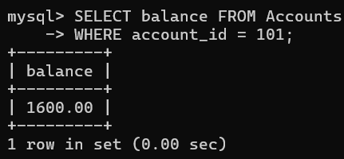

8. Write a SQL query to List all current accounts with a balance greater than $1,000.

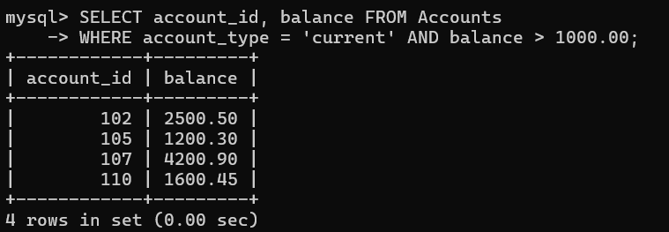

9. Write a SQL query to Retrieve all transactions for a specific account

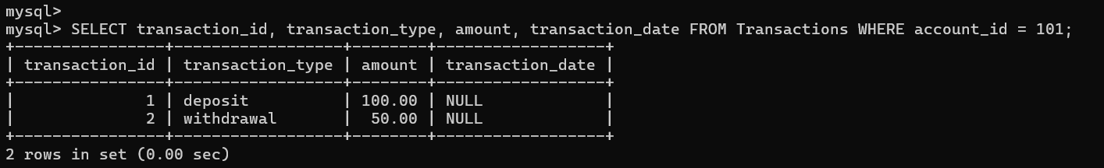

10. Write a SQL query to Calculate the interest accrued on savings accounts based on a given interest rate. **(NOTE:- INTEREST RATE 5%)**

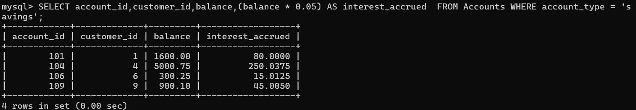

11. Write a SQL query to Identify accounts where the balance is less than a specified overdraft limit. **(NOTE:-OVERDRAFTING LIMIT = 800)**

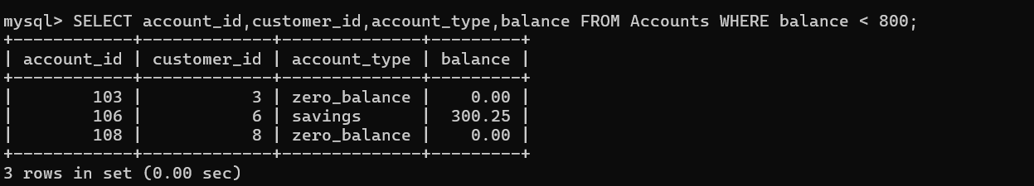

12. Write a SQL query to Find customers not living in a specific city.

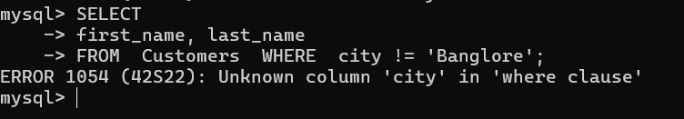

**Note:- There is no-city column mentioned**